Functions to improve for Calander tab.

CLICK TO SEARCH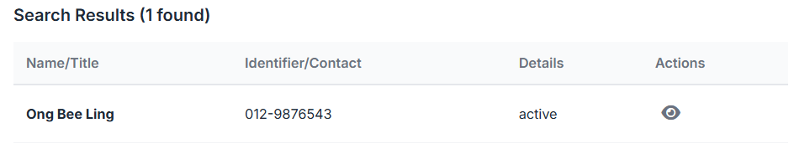
1. search results When click on the name should be direct to the prospect or customer profile.
2. add two more column, I want know agent name and status ( customer or prospect).
3. should be able to filter tag
4. should be able to filter need
5. should be able to find keyword
6. age range

Calander
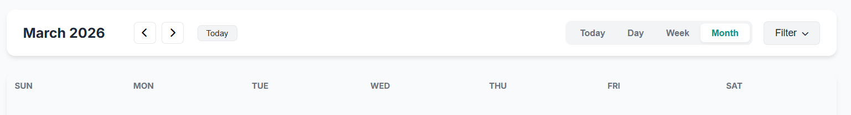
1. this calander function now is only 1 month march 2026, this is not correct. it should be the actual calander function. the calandar range should be from year 2010 until 2200, the calandar should be from Monday to Sunday presentation.

2. the filter button is not working.

3. the quick add activity button should be side the filter button.

4. this information should come with proper tabulate. Now look so messy.
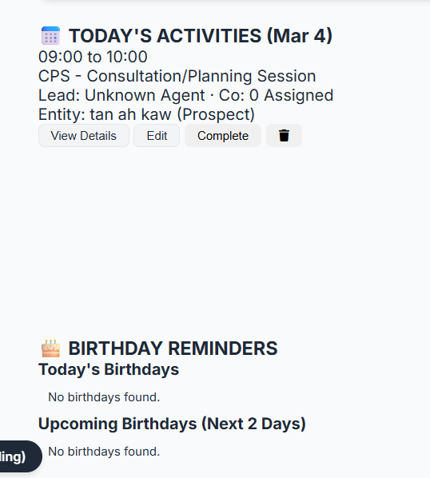

5. in calander view, the appointment display format, just the answer will do. The current answers only have time and customer name not sufficient. If got closing, then this information should be able to cascade at below.
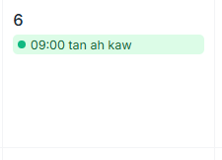
Time:
Agent Name:
Customer Name:
Activity type:
If closing, then only appear the information below.
Closed:
Product/ service name
Sales Amount:

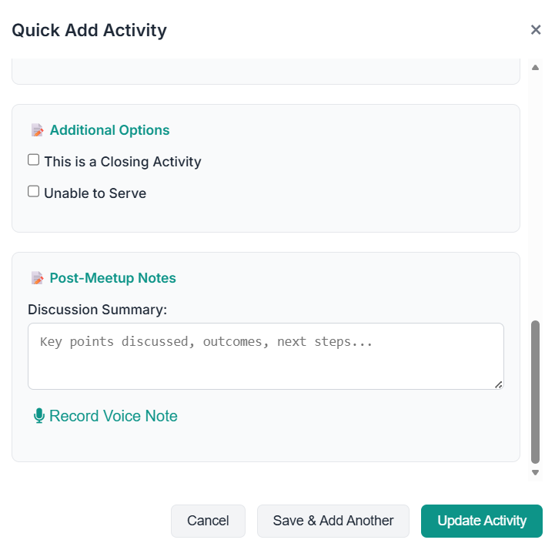
6. For the quick add activity
Need to add few more functions,
If is CPS, we will have hard copy paper. Can ask agent to attached this form
If closing, we need the closing details.
If is post meet up note, key points disccused, outcome, things to follow up, needs,all those need to split into different entry. Don’t join at one part. Same voice record note should be able to able for all entry field.

7. 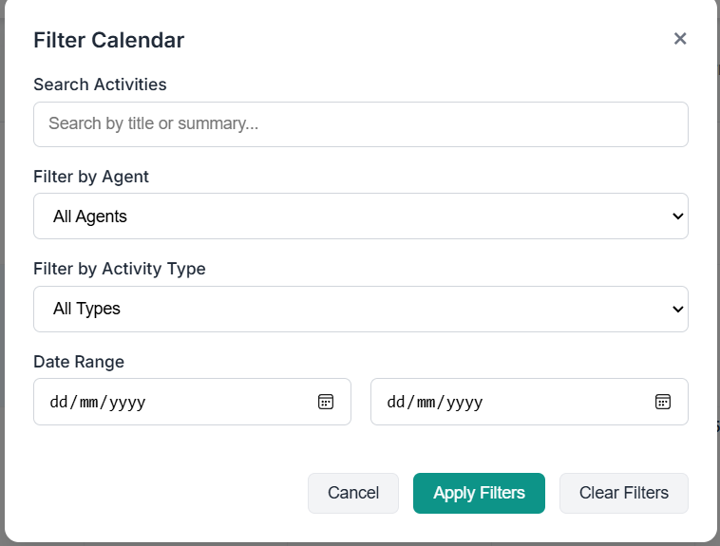
Add one more filter for this calander filter, for those appointment with case closed. It should able to filter out.

